How to move files into your Rstudio.cloud project space
Getting data or other scripts, markdown projects, etc. files into your project is a common work paradigm. You typically have two projects open in the “source pane” and typically toggle between them cutting and pasting the needed code blocks, changing variable names as needed. So suppose you have these files on your computer or a USB drive. How do you get them into your rstudio.cloud project?
Here I have a project in Dr J’s space called BBets
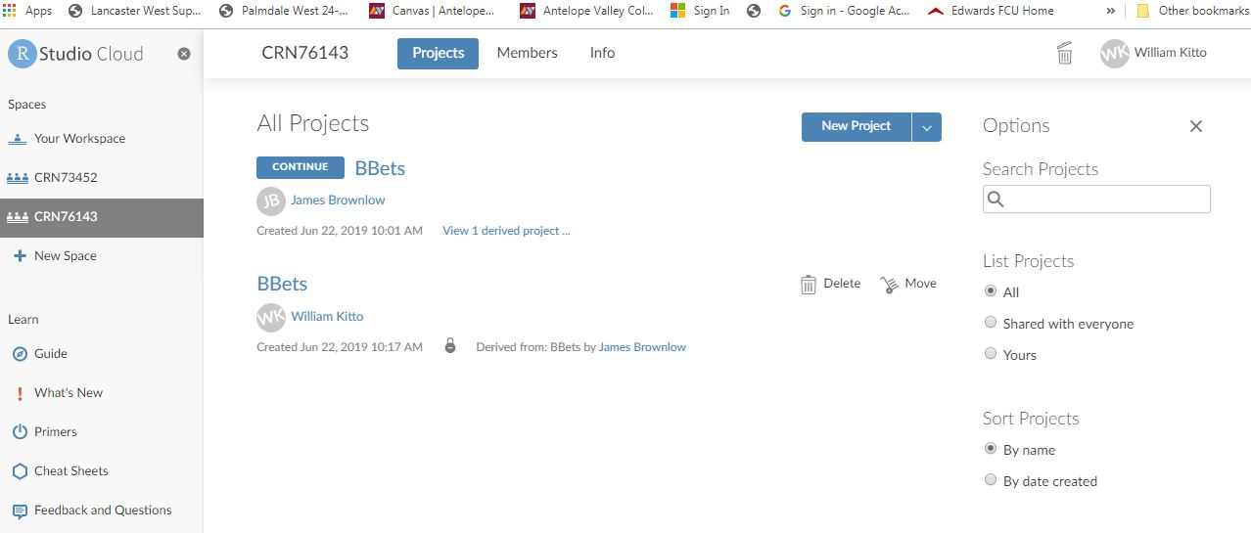
I want to import a plot_template markdown file I have on a USB stick, here is what’s in there now
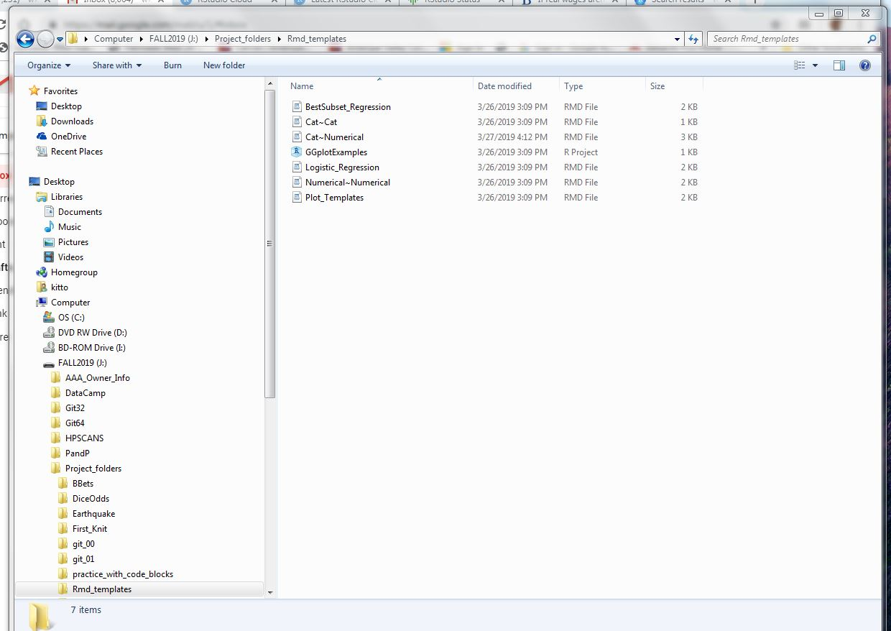

I will tell it to upload the plot_template

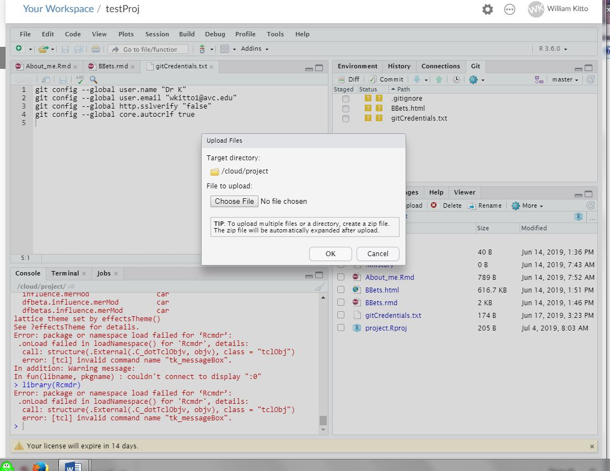

Now we highlight
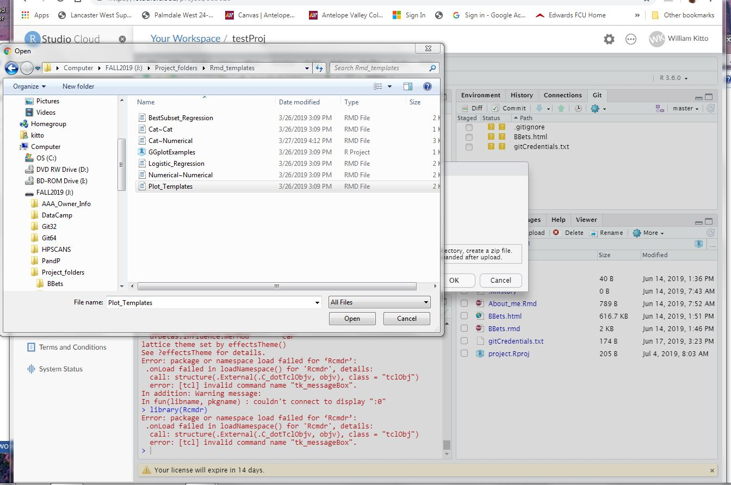

Then hit OK
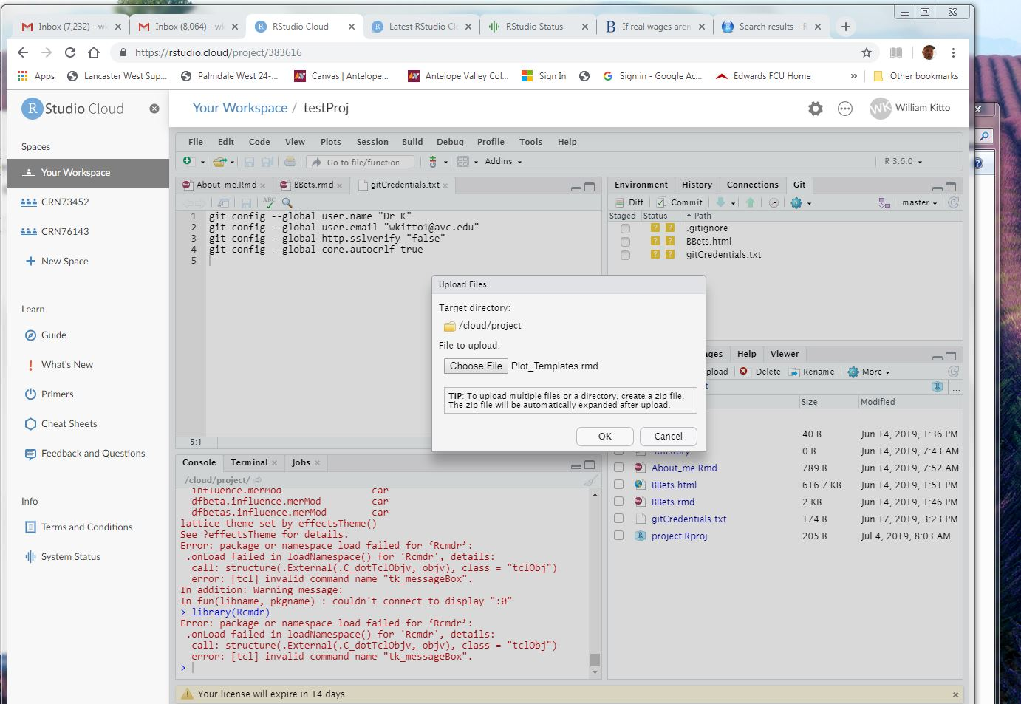

And we get our file in there

